**Homework 05 - Linked Lists**

**(1)** Implement the concepts of a union, and difference as defined noted in Chapter 1 questions 6, and 8 using a linked list. You should not use arrays, dynamic arrays or the STL vector or STL list classes.

You will be linking a series of nodes together to implement a single linked list class. Define a Node as a struct that holds a character (like they did in the book) and a pointer to another Node:

**struct Node {**

**char data;**

**Node* next;**

**};**

Then define a **LinkedList** class which has (at a minimum) these member functions:

**bool insertAtFront();**

**bool insertBeforePosition(int index);**

**bool insertAtBack();**

**bool deleteAtFront();  
bool deleteBeforePosition(int index);**

**bool deleteAtBack();**

Implement each of these functions to provide the correct functionality. These functions return true if successful in inserting or deleting, otherwise they return false (indicating the operation was not successful).

Finally, create an **overloaded + operator** to handle the Union of two linked lists and an **overloaded - operator** to handle the Difference of two linked lists.

Because we are dealing with pointers you should have both a LinkedList Constructor and Destructor. Remember that you do not directly call a Constructor or Destructor Function. The Destructor is automatically called when the variable loses scope or the program ends. Remember, that we are dealing with not just one dynamically allocated Node (with the new operator), but many, so you will have to start at the head of the list and go until the Node points to nullptr. Then keep deleting the previous Node pointer until there are no Nodes left to delete.

**(2)** To verify your set class, write a main function that takes two lines of characters from the input file **input.txt** and store each line of characters into two separate linked lists. Then using these two lists, perform the Union and set Difference of the characters from the file, and print the results to the console.

**(3)** Please also complete an asymptotic (Big O) analysis of your **insertAtFront()** and **insertAtBack()** member functions. Place this in a file called **analysis.txt**.

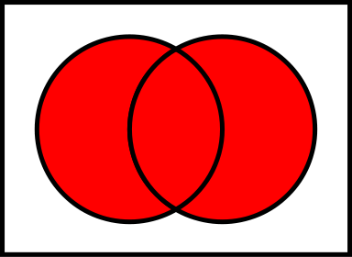 (Union) 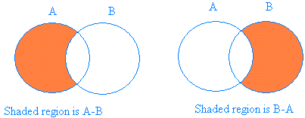 (Difference)